***ACTIVITY in GEM 605***

Chris Angelo Saavedra

Ivan John Naparota

Date: December 12, 2017

1. What is a random experiment?

* A random experiment is an experiment or process where the outcome cannot be predicted with certainty.

1. Is the 3 successive heads (3SH) activity a random experiment? Why?

* The activity in the first place, asks the experimenter for the necessary number of tosses that should be made to achieve three successive heads, as far as the definition of random experiment is concerned, the activity is a random experiment knowing that the experimenter is uncertain on the number of tosses necessary to get the desired scenario which is three consecutive heads, the experimenter can only be certain of one thing, that the minimum number of tosses should therefore be three(3) but the maximum number of tosses is of uncertainty, it could possibly be of a number which is too large to be counted.

1. What is a sample space?

* Sample space is the set of all possible outcomes in a random experiment.

1. What is the sample space of the 3SH activity?

* By definition, sample space is *the set of possible outcomes in a random experiment,* the only thing the experimenter is certain is the number of minimum tosses necessary to get three (3) consecutive heads which is three(3), so the set of possible outcomes therefore starts from three (3) tosses which is of course HHH (three heads in succession) until to the uncertain largest number (it could be in thousands, or it could be in millions) of tosses, still it is mathematically possible.

1. Obtain a general equation for the probability function of the 3SH activity.

Solving manually for the probabilities of the different toss counts, but limiting only up to eight (8) number of tosses:

* For three (3) toss counts:

|  |  |
| --- | --- |
| Possible Arrangements | Probability |
| HHH | .5 x .5 x .5 = **0.125 or 1/8** |

* For four (4) toss counts:

|  |  |
| --- | --- |
| Possible Arrangements | Probability |
| THHH | .5 x .5 x .5 x .5 = **0.0625 or 1/16** |

* For five (5) toss counts:

|  |  |
| --- | --- |
| Possible Arrangements | Probability |
| TTHHH | .5 x .5 x .5 x .5 x .5 = 0.03125 |
| HTHHH | .5 x .5 x .5 x .5 x .5 = 0.03125 |
|  | **.0625 or 2/32** |

* For six (6) toss counts:

|  |  |
| --- | --- |
| Possible Arrangements | Probability |
| HHTHHH | .5 x .5 x .5 x .5 x .5 x .5 = 0.015625 |
| TTTHHH | .5 x .5 x .5 x .5 x .5 x .5 = 0.015625 |
| HTTHHH | .5 x .5 x .5 x .5 x .5 x .5 = 0.015625 |
| THTHHH | .5 x .5 x .5 x .5 x .5 x .5 = 0.015625 |
|  | **0.0625 or 4/64** |

* For seven (7) toss counts:

|  |  |
| --- | --- |
| Possible Arrangements | Probability |
| TTTTHHH | .5 x .5 x .5 x .5 x .5 x .5 x .5 = 0.0078125 |
| TTHTHHH | .5 x .5 x .5 x .5 x .5 x .5 x .5 = 0.0078125 |
| THTTHHH | .5 x .5 x .5 x .5 x .5 x .5 x .5 = 0.0078125 |
| HTHTHHH | .5 x .5 x .5 x .5 x .5 x .5 x .5 = 0.0078125 |
| HHTTHHH | .5 x .5 x .5 x .5 x .5 x .5 x .5 = 0.0078125 |
| THHTHHH | .5 x .5 x .5 x .5 x .5 x .5 x .5 = 0.0078125 |
| HTTTHHH | .5 x .5 x .5 x .5 x .5 x .5 x .5 = 0.0078125 |
|  | **0.0546875 or 7/128** |

* For eight (8) toss counts:

|  |  |
| --- | --- |
| Possible Arrangements | Probability |
| HTTTTHHH | .5 x .5 x .5 x .5 x .5 x .5 x .5 x .5 = 0.00390625 |
| HTTHTHHH | .5 x .5 x .5 x .5 x .5 x .5 x .5 x .5 = 0.00390625 |
| HTHTTHHH | .5 x .5 x .5 x .5 x .5 x .5 x .5 x .5 = 0.00390625 |
| HTHHTHHH | .5 x .5 x .5 x .5 x .5 x .5 x .5 x .5 = 0.00390625 |
| HHTTTHHH | .5 x .5 x .5 x .5 x .5 x .5 x .5 x .5 = 0.00390625 |
| HHTHTHHH | .5 x .5 x .5 x .5 x .5 x .5 x .5 x .5 = 0.00390625 |
| TTTTTHHH | .5 x .5 x .5 x .5 x .5 x .5 x .5 x .5 = 0.00390625 |
| TTTHTHHH | .5 x .5 x .5 x .5 x .5 x .5 x .5 x .5 = 0.00390625 |
| TTHTTHHH | .5 x .5 x .5 x .5 x .5 x .5 x .5 x .5 = 0.00390625 |
| TTHHTHHH | .5 x .5 x .5 x .5 x .5 x .5 x .5 x .5 = 0.00390625 |
| THHTTHHH | .5 x .5 x .5 x .5 x .5 x .5 x .5 x .5 = 0.00390625 |
| THTHTHHH | .5 x .5 x .5 x .5 x .5 x .5 x .5 x .5 = 0.00390625 |
| THTTTHHH | .5 x .5 x .5 x .5 x .5 x .5 x .5 x .5 = 0.00390625 |
|  | **0.05078125 or 13/256** |

From the above solution, the probabilities of three (3) tosses up to eight (8) tosses are as follows:

$\frac{1}{8}$, $\frac{1}{16}$, $\frac{2}{32}$, $\frac{4}{64}$, $\frac{7}{128}$, $\frac{13}{256}$

Let us observe the solved probabilities, it is noticeable that each denominator can simply be expressed to $2^{n}$, where **n** is the number of tosses.

On the other hand, the numerator is noticed to manifest the characteristic of the sequence named Tribonacci, Tribonacci sequence is a generalization of the Fibonacci sequence, the sequence starts with three predetermined terms and each term afterwards is the sum of the preceding three terms.

|  |
| --- |
|  |

The first few Tribonacci numbers are: 0, 0, 1, 1, 2, 4, 7, 13, 24, 44, 81, 149, 274, 504, 927, 1705 and so on.

Tribonacci Sequence Formula:

$$T_{n}=\left\{3C\left[\frac{{\left(\frac{1}{3}\left(A+B+1\right)\right)}^{n}}{C^{2}-2C+4}\right]\right\}$$

Where:

$$A= \sqrt[3]{19+3\sqrt{33}}$$

$$B= \sqrt[3]{19-3\sqrt{33}}$$

$$C= \sqrt[3]{586+102\sqrt{33}}$$

and *T* is rounded to the nearest integer.

But acknowledge that the start of the series is at three (3) tosses which has a *T* of 1 followed by four (4) tosses also having a *T* of 1, and five (5) tosses having a *T* of 2, when letting ***T***as a Tribonacci number.

It is then conclusive that we can let the denominator be expressed as $T_{n-2}$, letting **n** as the number of tosses.

The general formula for the probability of each tosses is hereby presented as:

$$P_{n}= \frac{\left\{3C\left[\frac{{\left(\frac{1}{3}\left(A+B+1\right)\right)}^{n-2}}{C^{2}-2C+4}\right]\right\}}{2^{n}}$$

Where **n** is the number of tosses.

1. Show that your probability function is validated by simulation.

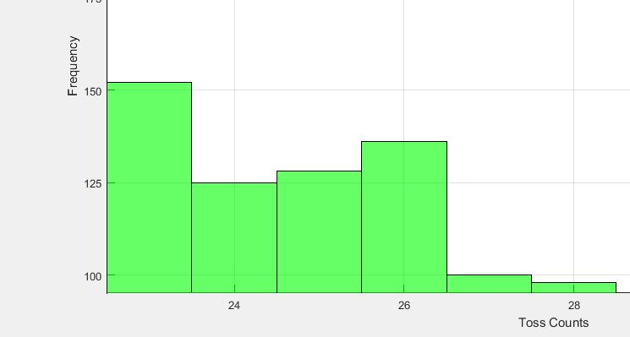

Figure 1.Simulation from MATLAB with 10,000 outcomes considered (Magnified View)

Setting twenty-seven (27) tosses as an example, it has a frequency of one-hundred (100). It implies that the probability of tossing twenty-seven (27) times is $\frac{100}{10000}$ or **0.0100**. Now, let us compare if it has the same result if we’ll use the made formula,

Considering,

n = 27, $A= \sqrt[3]{19+3\sqrt{33}}$ = 3.30905648

$B= \sqrt[3]{19-3\sqrt{33}}$ = 1.208803786

$C= \sqrt[3]{586+102\sqrt{33}}$ = 10.5431194

$P_{27}= \frac{\left\{3C\left[\frac{{\left(\frac{1}{3}\left(A+B+1\right)\right)}^{n-2}}{C^{2}-2C+4}\right]\right\}}{2^{n}}$ = $\frac{\left\{3(10.5431194)\left[\frac{{\left(\frac{1}{3}\left(3.30905648+1.208803786+1\right)\right)}^{27-2}}{{10.5431194}^{2}-2(10.5431194)+4}\right]\right\}}{2^{27}}$

= **0.0103 ≈ 0.0100**

They may not have exactly the same decimal digits, but it is still conclusive that the simulation delivers the same result to the formulated formula because their values are approximately equal.